## **Angular & Node Connectivity**

## 

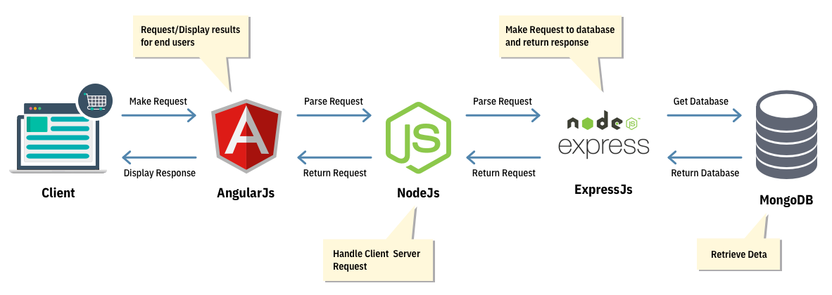

* Initially, it begins with Angular.js where all the requests emerging from the client-side are processed.
* Once the initial phase is over, the request enters to Node which is in control of the server-side.
* The request enters to Express.js where it requests for database access.
* MongoDB collects the entire data once the request is accepted and relays it to Express.js
* Express relays the response to Node which sends it to Angular.

## **REST API**

It means when a RESTful API is called, the server will transfer to the client a representation of the state of the requested resource.

For example, when a developer calls Instagram API to fetch a specific user (the resource), the API will return the state of that user, including their name, the number of posts that user posted on Instagram so far, how many followers they have, and more.

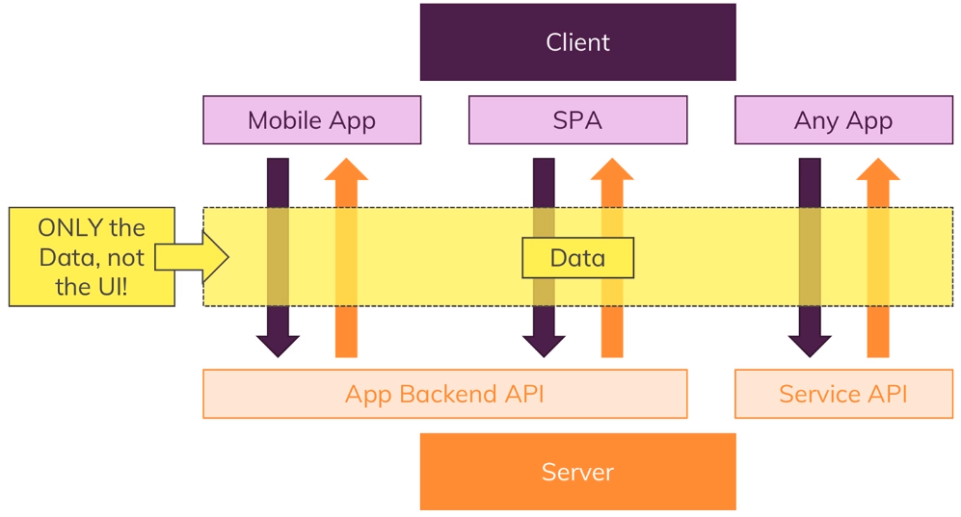

## **Data Format**

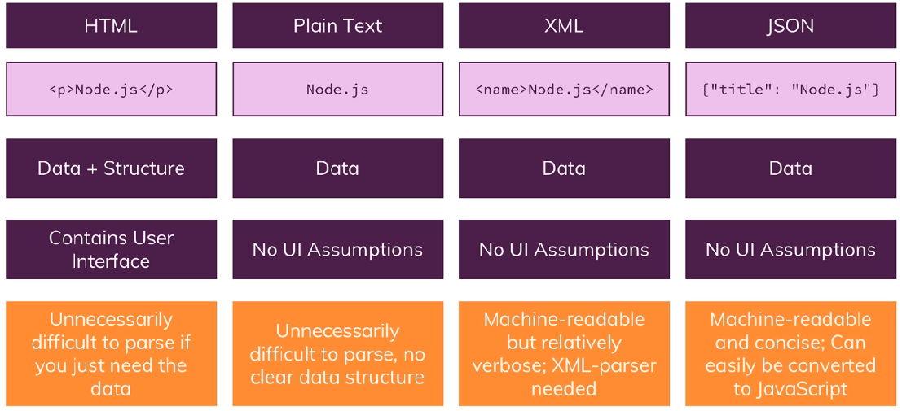

## **RESTful APIs are Stateless Backends**

